JJBS News Release
24 June 2021
Jewish Joint Burial Society opens Woodland Hall at the Woodland Cemetery, Cheshunt
The fixing of the mezuzah on the doors of the Woodland Hall and offices at the JJBS Woodland Cemetery, Cheshunt marks the opening of the new facilities at the only dedicated Woodland Cemetery for Jewish burials in Britain which was created in 2011. The new Hall complements the Woodland Prayer Hall and provides a beautiful space for families to meet their families and friends for light refreshments before and after funerals and stone settings. The new building has been designed by architect David Green to the highest environmental standards with a ground source heat pump providing heating and water and photovoltaic panels providing solar electricity. The building is constructed of wood with a sedum covered roof to act as insulation. The JJBS offices have now relocated to the Woodland Cemetery from Wanstead.
Steve Wynne, the newly elected Chairman of JJBS says:
“The Woodland Cemetery provides an attractive environmentally friendly location for Jewish funerals totally in keeping with Jewish principles of concern for protecting our surroundings. The new Hall provides a valuable additional resource for families at a time of bereavement. I would like to thank David Leibling, the outgoing chairman, for his efforts in bringing this project to fruition.”
The JJBS Woodland Cemetery allows members to choose to be buried in an environmentally-friendly way, in a beautiful natural environment, surrounded by newly planted trees. The burial can include a coffin made from plain wood, bamboo or wicker, all which decompose naturally. The graves are marked with natural meadow plants or can be left to naturalise under the trees with the option of a small flat memorial stone. The Lawn section provides a green alternative for Jewish and non-Jewish burials, with graves being marked by a simple upright stone. Members can pay tribute to a loved one by planting a memorial tree. There is also a columbarium for the interment of cremated ashes.
The Jewish Joint Burial Society, founded in 1969, provides funerals for synagogue members as part of the benefits of belonging to a synagogue and also in line with the duty to respect the dead, provides funerals for people who are not affiliated to a synagogue. Currently, the JJBS covers 18,000 members in 43 synagogues (28 Reform, 9 Masorti, 4 Liberal and 2 Independent). Besides the Woodland Cemetery, JJBS buries at the Western Cemetery Cheshunt, and dedicated areas at New Southgate Cemetery and Randalls Park and Kemnal Park Cemeteries. For funerals outside the south east, JJBS covers the costs for burials in local cemeteries.

Contact details
Steve Wynne
JJBS Office 020 8989 5252
Chair@jewishfunerals.org.uk

Fixing mezuzah at JJBS Woodland Hall 22 June 2021
From left to right Mitzi Kalinsky Senior Sexton, Steve Wynne Chairman, David Leibling outgoing Chairman, Frank Godson Hon. President, David Green Architect, Ian Jacobs Sexton
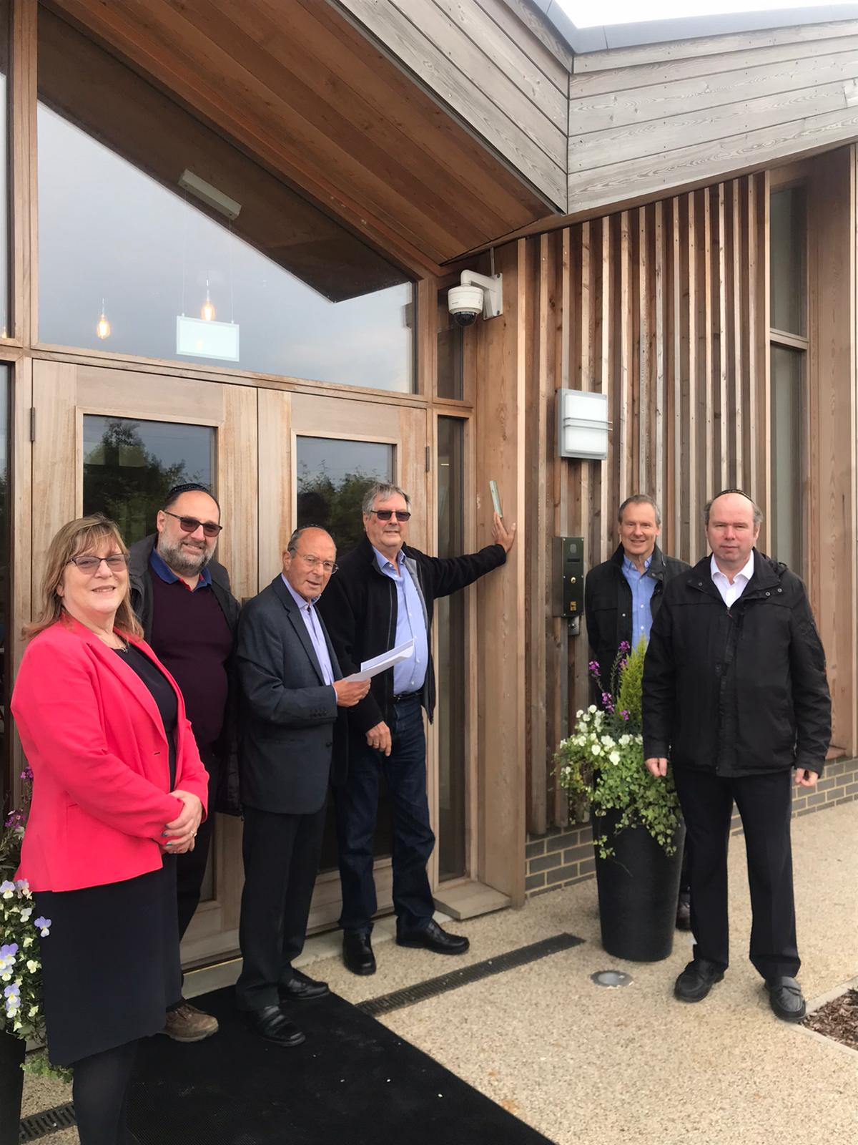
Woodland Hall and offices
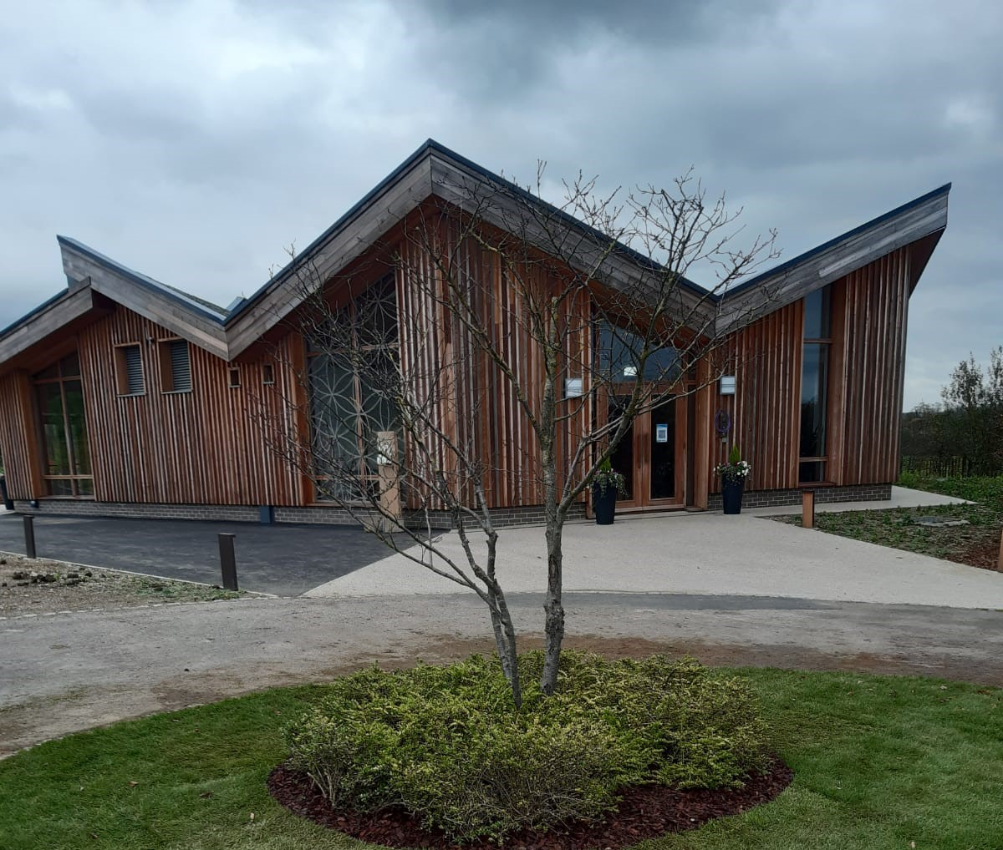
Woodland Hall interior
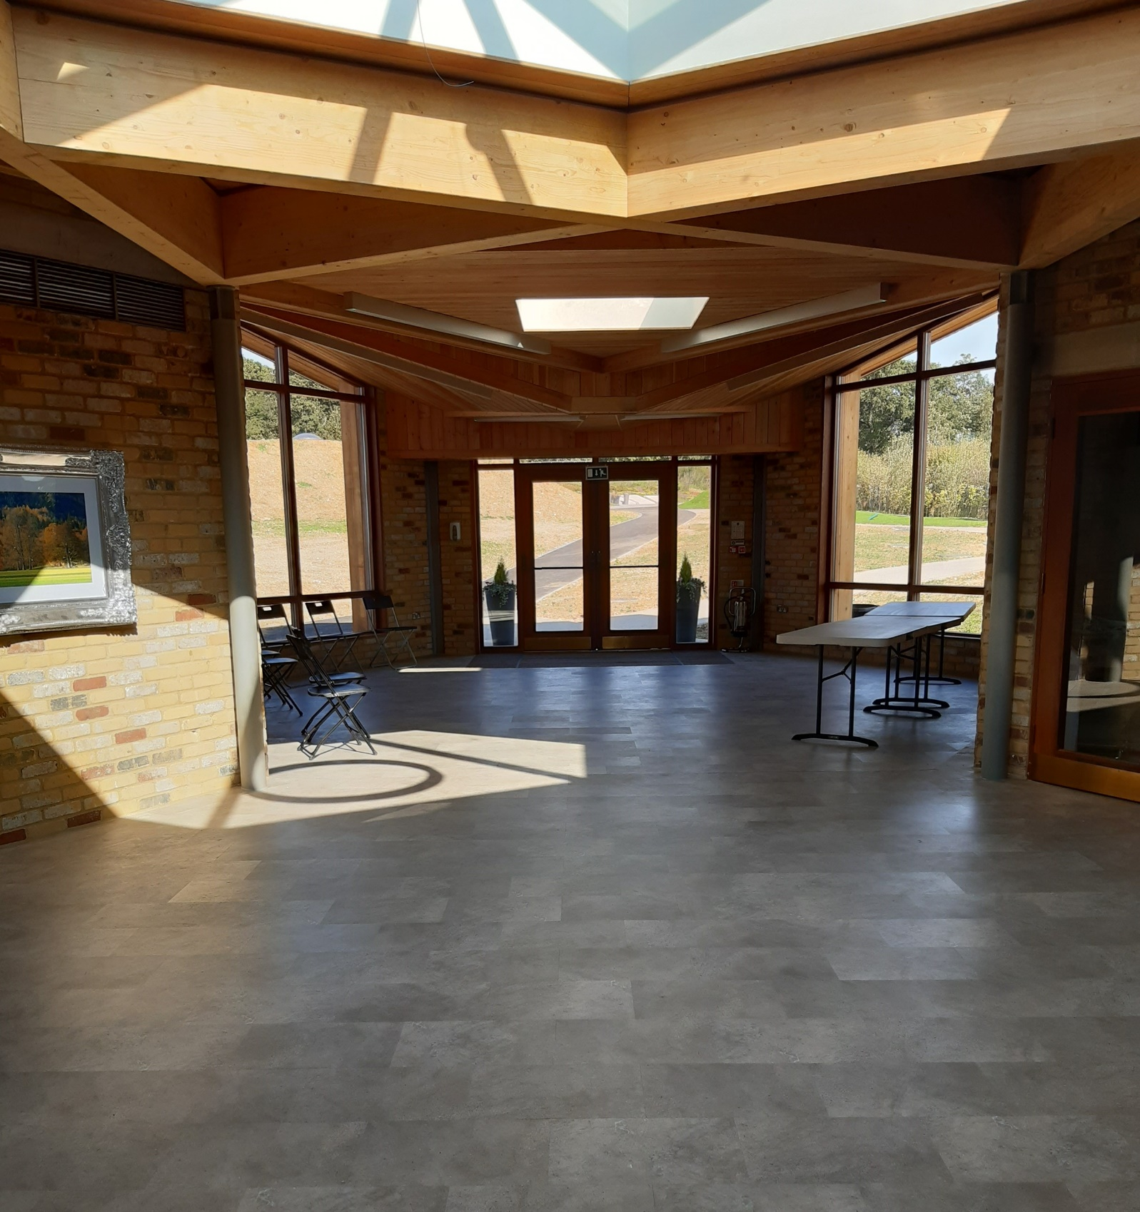

Woodland Cemetery

